Diabetes Application Documentation and UML

Application UML Document:



Documentation:

When starting the application, the user is presented with a splash screen and three buttons from which all application functionality is available:

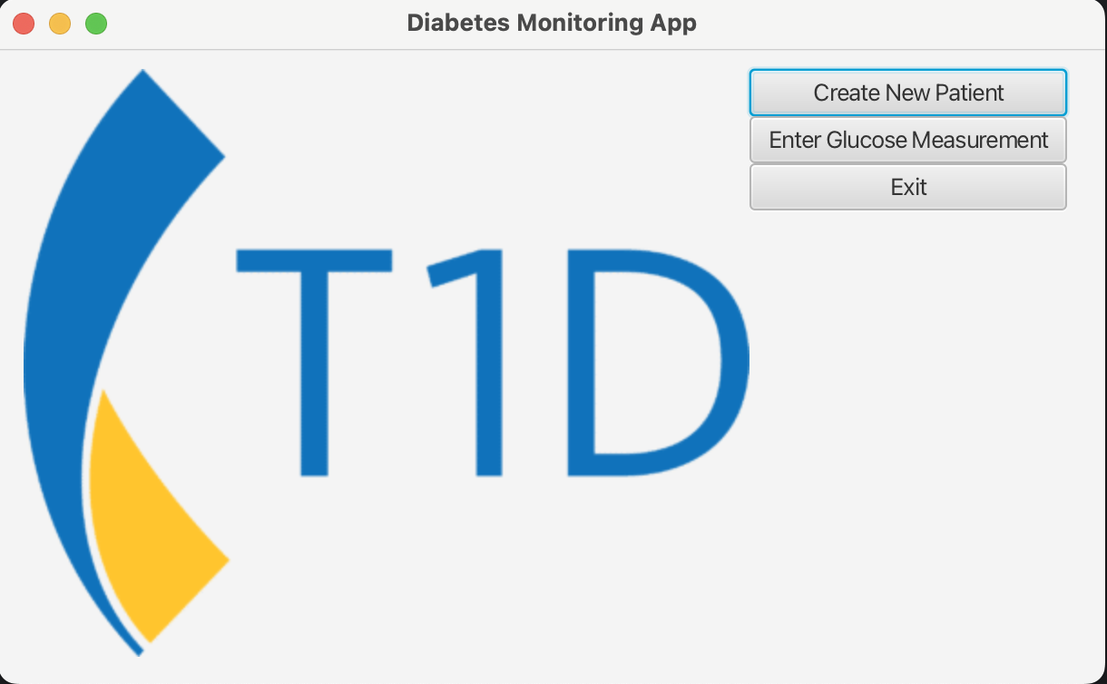

When the user clicks on the “Create New Patient” button, the user can enter a new patient or load an existing patient from a binary file saved off previously:

If the user clicks on the “Enter Glucose Measurement” button, the user is presented with a screen through which he can enter a glucose measurement or load previously saved glucose measurements:

